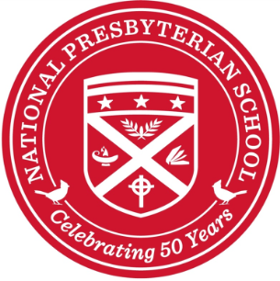

School Chaplain

National Presbyterian School, an independent, coeducational elementary (Nursery-6th Grade) school located in Washington, DC, is conducting a search for a Chaplain beginning with the 2019-2020 school year.

The Chaplain is responsible for coordination and leadership for spiritual growth, religious education, pastoral care, and service learning at the 300-student school, as well as serving as an liaison with National Presbyterian Church. As a member of the administrative team, the Chaplain reports to the Head of School and works closely with teachers and administrators throughout the school. The role of NPS Chaplain is a full-time, 10-month a year position (late August through mid-June).

Primary responsibilities include:

      - Teach Religious Studies to Grades 2-6, (each class meets once every 6-day rotation)
- Coordinate two weekly Chapel services, Lower Division (Nursery—1st Grade) on Wednesdays, Upper Division (2nd—6th Grade) on Thursdays
- Resource and coordinate Service Learning Projects done by each grade, as well as all-school Service Learning efforts
- Respond to pastoral situations and serving as available presence for students, staff, and families
- Plan and lead special school services – faculty Back to School Chapel, Thanksgiving, Christmas, Graduation, and all-school Chapels
- Represent the school at various forums and events
- Maintain connection with National Presbyterian Church and explore school-church partnership opportunities
- Maintain and fulfill requirements of a specialized minister in the National Capital Presbytery

In candidates, NPS is looking for the following:

- Ordained clergy, preferably in the PC(USA), or on the path to ordination
- Experience in worship leadership, pastoral care, and teaching children
- Excellent listener and communicator, with strong interpersonal skills and an ability to collaborate with colleagues
- Strong organizational skills, demonstrates creativity and resourcefulness
- Embodies compassion, warmth, and encouragement; generates trusts among all constituencies
- Leader and role model for faculty & staff, students, and parents

Individuals interested in applying for this position should send a resume, cover letter, references, and a statement of faith to Laura Ferrara, Executive Assistant to the Head of School, at lferrara@nps-dc.org, by April 30, 2019.

Questions: Please contact Head of School Malcolm Lester at malcolm.lester@nps-dc.org, 202-537-7545

